https://www.udemy.com/course/modern-javascript-from-the-beginning/learn/lecture/37191462#overview
35 Basic Functions
Parameters vs. Arguments
Parameters are the names of the variables that are used to pass data into a function.
Arguments are the values that are passed into the function
36 More on Params and Arguments
Default Params -In ES6 can set a default param so that it is used in no argument is passed into the function
Rest Params The rest parameter syntax allows a function to accept an indefinite number of arguments as an array.
Objects as params
Arrays as params
37 Global Function Scope
Window is global scope all on its own
Global scope variable- at the top , outside of the functions that follow
38 Block Scope
Block Statement A block statement is used to group zero or more statements. The block is delimited by a pair of braces ("curly braces") and contains a list of zero or more statements and declarations.
Const and let defined inside of block is not available outside of the block but var is, most of the time one would want variables to be block scoped. Cleaner more understandable code using let and const avoid var.
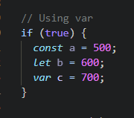
Also note that var in a function is function scoped , it is in a block that it is not.
39 Nested Scope
JavaScript allows nested blocks and therefore nested scopes. Nested scopes create a scope tree or scope chain. As expected, we can access variables from their direct scope (the scope where they get declared). We can also access variables from their inner scopes (the scopes that nest within their direct scope).
40 Function Declaration vs Function Expression 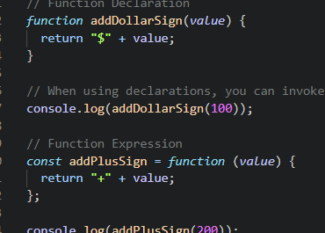
Invoke them the same way. There are some differences related to hoisting. (execution context) .In simple terms, hoisting is the process of moving all the function and variable declarations to the top of the current scope before the code is run. So you can think of it before your code is actually executed. You can think of a step before that where it goes through and it looks for all your function declarations and your expressions and your variables and puts all those at the top of the page. Now, even though this happens, only function declarations are available before the code is executed.
41 Arrow Functions ES -6 compact and explicit returns
An arrow function expression is a compact alternative to a traditional function expression, with some semantic differences and deliberate limitations in usage:
Arrow functions don't have their own bindings to this, arguments, or super, and should not be used as methods.
Arrow functions cannot be used as constructors. Calling them with new throws a TypeError. They also don't have access to the new.target keyword.
Arrow functions cannot use yield within their body and cannot be created as generator functions.

Normal function declaration -
https://developer.mozilla.org/en-US/docs/Web/JavaScript/Reference/Functions/Arrow_functions

function add(a, b) {
return a + b;
}
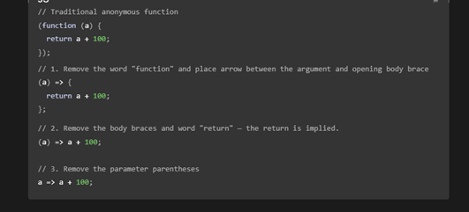
Arrow function syntax
const add = (a, b) => {
return a + b;
};
Implicit Return
const subtract = (a, b) => a - b;
Can leave off () with a single param
const double = (a) => a * 2;
Returning an object
const createObj = () => ({
name: "Brad",
});
42 – Immediately Invoked Function Expressison IIFEs
https://developer.mozilla.org/en-US/docs/Glossary/IIFE

43- Challanges
- You can use `Math.min()` and `Math.max()` to get the min and max of a list of numbers.
- Pass the array in using spread
44 Execution Context -special environment created to handle transformation and execution of code.
When the JavaScript engine scans a script file, it makes an environment called the Execution Context that handles the entire transformation and execution of the code.
During the context runtime, the parser parses the source code and allocates memory for the variables and functions. The source code is generated and gets executed.
There are two types of execution contexts: global and function. The global execution context is created when a JavaScript script first starts to run, and it represents the global scope in JavaScript. A function execution context is created whenever a function is called, representing the function's local scope.
Phases of the JavaScript Execution Context
There are two phases of JavaScript execution context:
- Creation phase: In this phase, the JavaScript engine creates the execution context and sets up the script's environment. It determines the values of variables and functions and sets up the scope chain for the execution context.
- Execution phase: In this phase, the JavaScript engine executes the code in the execution context. It processes any statements or expressions in the script and evaluates any function calls.
Everything in JS happens inside this execution context. It is divided into two components. One is memory and the other is code. It is important to remember that these phases and components are applicable to both global and functional execution contexts.
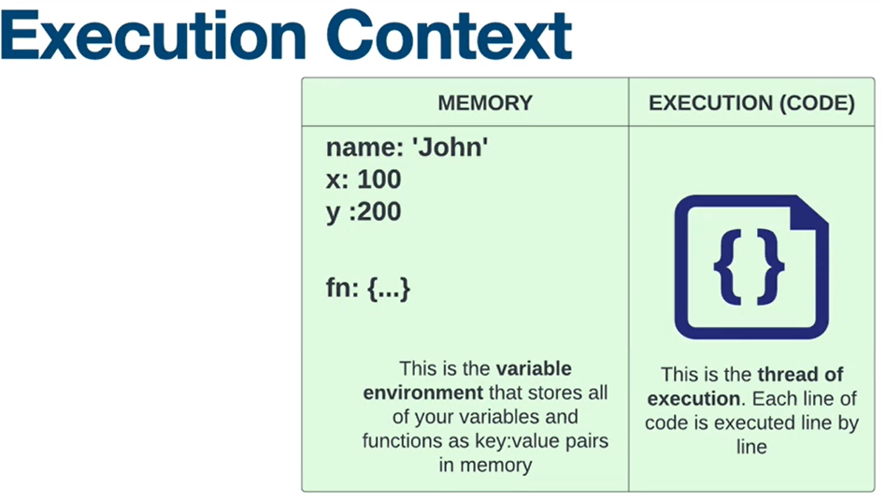
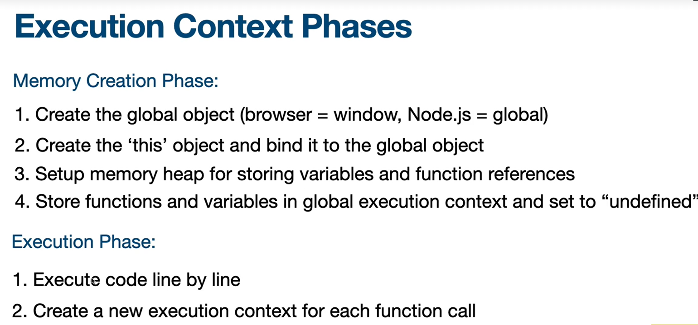
45 Execution Context in action
46 The Call Stack
Call stack
A call stack is a mechanism for an interpreter (like the JavaScript interpreter in a web browser) to keep track of its place in a script that calls multiple functions — what function is currently being run and what functions are called from within that function, etc.
- When a script calls a function, the interpreter adds it to the call stack and then starts carrying out the function.
- Any functions that are called by that function are added to the call stack further up, and run where their calls are reached.
- When the current function is finished, the interpreter takes it off the stack and resumes execution where it left off in the last code listing.
- If the stack takes up more space than it was assigned, a "stack overflow" error is thrown.

